**Testing Document:**

**Testing for String:**

**Unsorted Array:**

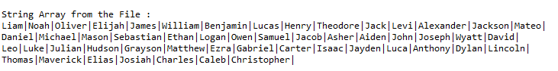

**Result from Sorting:**

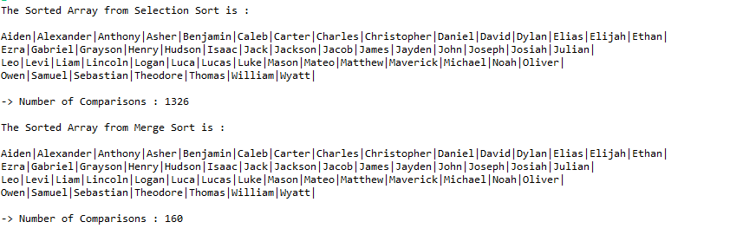

**Result:**

**Pass, we can see that the elements are sorted**

**Result from Searching:**

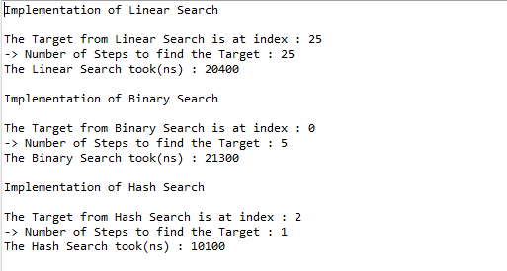

**Result:**

**Linear Search:**

Pass, We can see that Aiden is in 25 position in unsorted array

**Binary Search:**

Pass,We can see that Aiden is at index 0 in sorted array

**Hash:**

Since the size of string array is around 54 the value of length of our array will be 80(As we are doubling in terms of 10)

Since we use hash as Sum of ascii chars of string % ar Length.

Sum of Ascii for Aiden:481, so hash:481%80=1

Aiden is at index 1 in hash array.

**Testing for Integer:**

**Unsorted Array:**

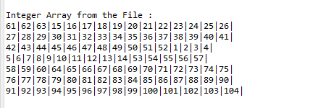

**Result from Sorting:**

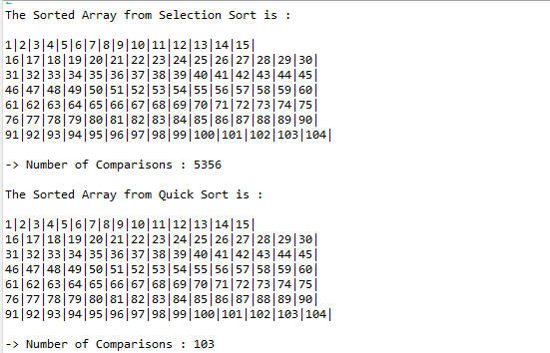

**Result from Searching:**

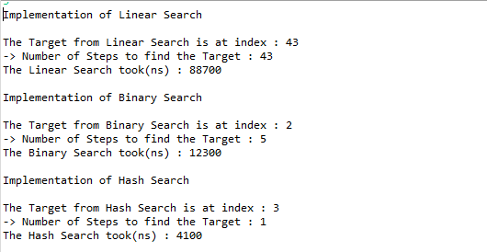

**Result:**

**Linear Search:**

Pass, We can see that 3 is at index 43 in unsorted Array

**Binary Search:**

Pass, We can see that 3 is at index 2 in sorted Array

**Hash:**

Since the size of string array is around 104 the value of length of our array will be 160(As we are doubling in terms of 10)

Since we use hash as value of int % ar Length.

Target:3, so hash:3%160=3

3 is at index 3 in hash array.

**Testing for Float:**

**Unsorted Array:**

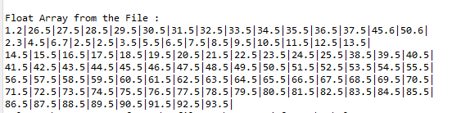

**Result from Sorting:**

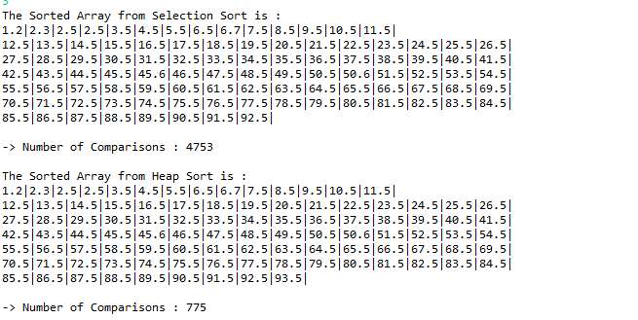

**Result from Searching:**

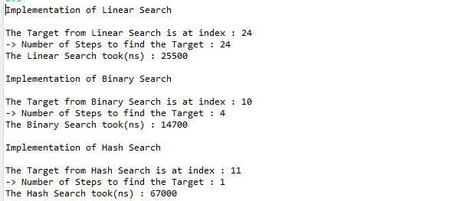

**Result:**

**Linear Search:**

Pass, We can see that 8.5 is at index 24 in unsorted Array

**Binary Search:**

Pass, We can see that 3 is at index 10 in sorted Array

**Hash:**

Since the size of string array is around 98 the value of length of our array will be 160(As we are doubling in terms of 10)

Since we use hash as value of float 8 % ar Length.

Target:8.5, so hash:8%160=8

May be the hash value of 8 is already occupied by other element so the 8.5 is placed at index 11 which might be free.